The Wagga Wagga Boat Club

**Function Package**

Birthdays, Weddings, Anniversaries, Dinners & More.

**CONTACT INFORMATION:**

Nelson Drive (Off Plumpton Road), Wagga Wagga NSW 2650

**Telephone: (02) 6926 2300**

Email: waggawaggaboatclub@bigpond.com

Website: www.waggawaggaboatclub.com

Find us on Facebook: The Wagga Wagga Boat Club

**ABN: 23 001 064 106**

**Why choose us?**

Do you want a function venue with spectacular views, first class service and

fabulous food? Look no further than The Wagga Wagga Boat Club Function

Centre. Located on stunning Lake Albert, our second-floor function facilities offer

an unmatched lake view with unique open air or inside areas.

Our recent refurbishment has seen some spectacular changes to the function

rooms creating a venue that cannot be beaten on location, atmosphere or value.

It allows you to enjoy the location, view, and atmosphere no matter what the

weather is doing outside.

**Function Areas**

**Upstairs Function area** including the balcony and bar are

available to hire for privately for a very competitive price of **$350.00** and can accommodate anywhere.

from 80 to 120 guests seated with dance floor or 180 guests seated without the dance

floor. **Upstairs can only be booked for a Min 80 guests Sit down or buffet menu only.**

**Deck Booking** Privately **$300.00,** if you would like your own private bar on the deck, an Extra charge of $200.00.

**Downstairs Sandbar and Alfresco area** is available with **Zero**

**Room Hire fee** but a $200 security deposit is required when making a booking.

This area is a public area and therefore people not from your

function may be present.

**Full Bar Facilities**

Offering the convenience of a Bar Tab for you and your guests, our bar facilities are

more than capable of catering to your every need.

**Entertainment**

Let us know your entertainment requirements and we can recommend a range of

suitable live entertainers for your special night. We also have iPod connectivity and

microphone available if you require.

**Courtesy Bus**

Forget about the worry of organizing travel arrangements and let our friendly staff take

care of your guests with pick up and drop offs in the local area. It’s all part of the

service.

**Personal Service**

You are invited to drop in and see Anna – our dedicated Functions Manager. Discuss

the details of your function and let her attention to detail and expertise make your

function one to remember.

**STRICTLY NO CONFETTI, SPINKLES, PETALS OR BALLONS CONTAINING ANY.**

*Menu’s*



*Crystal Restaurant*

*at*

*The Wagga Wagga Boat Club*

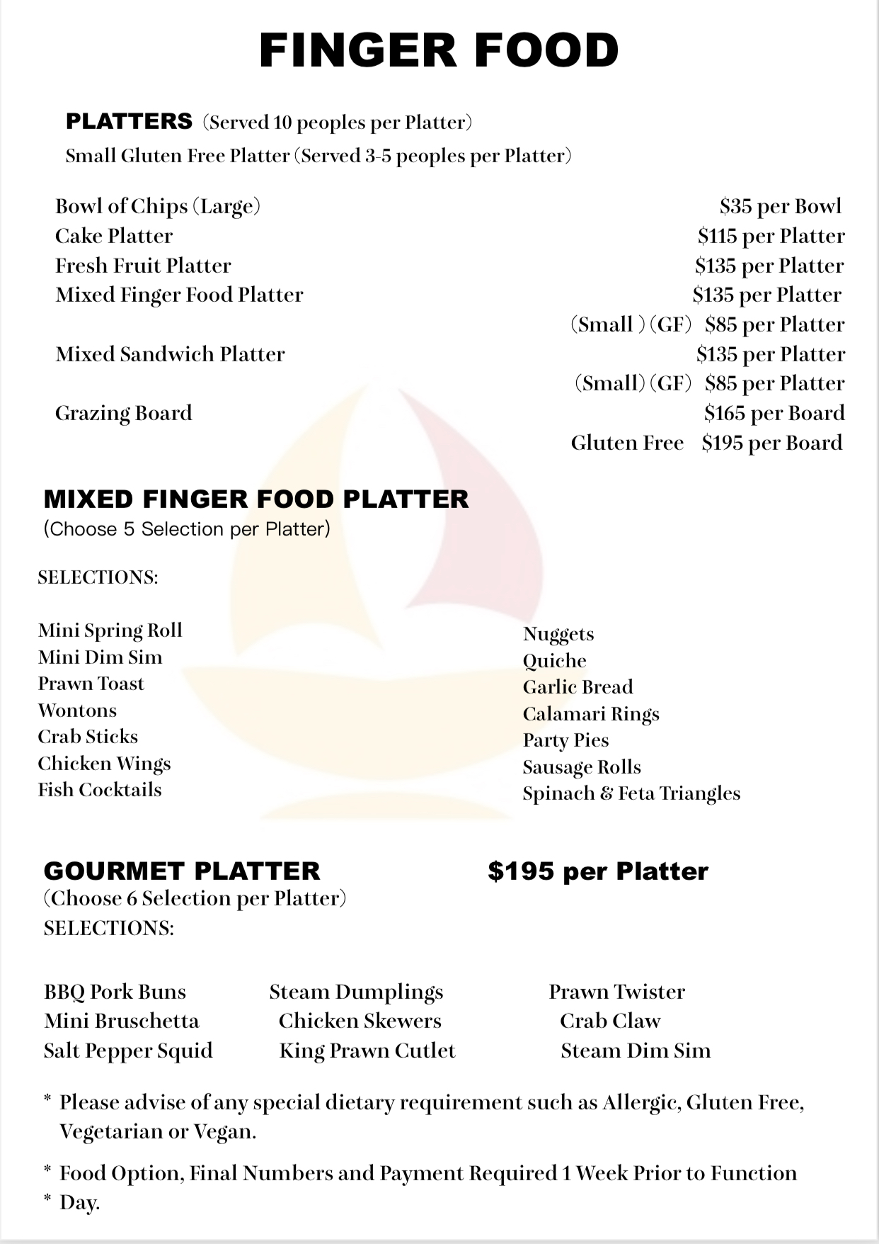

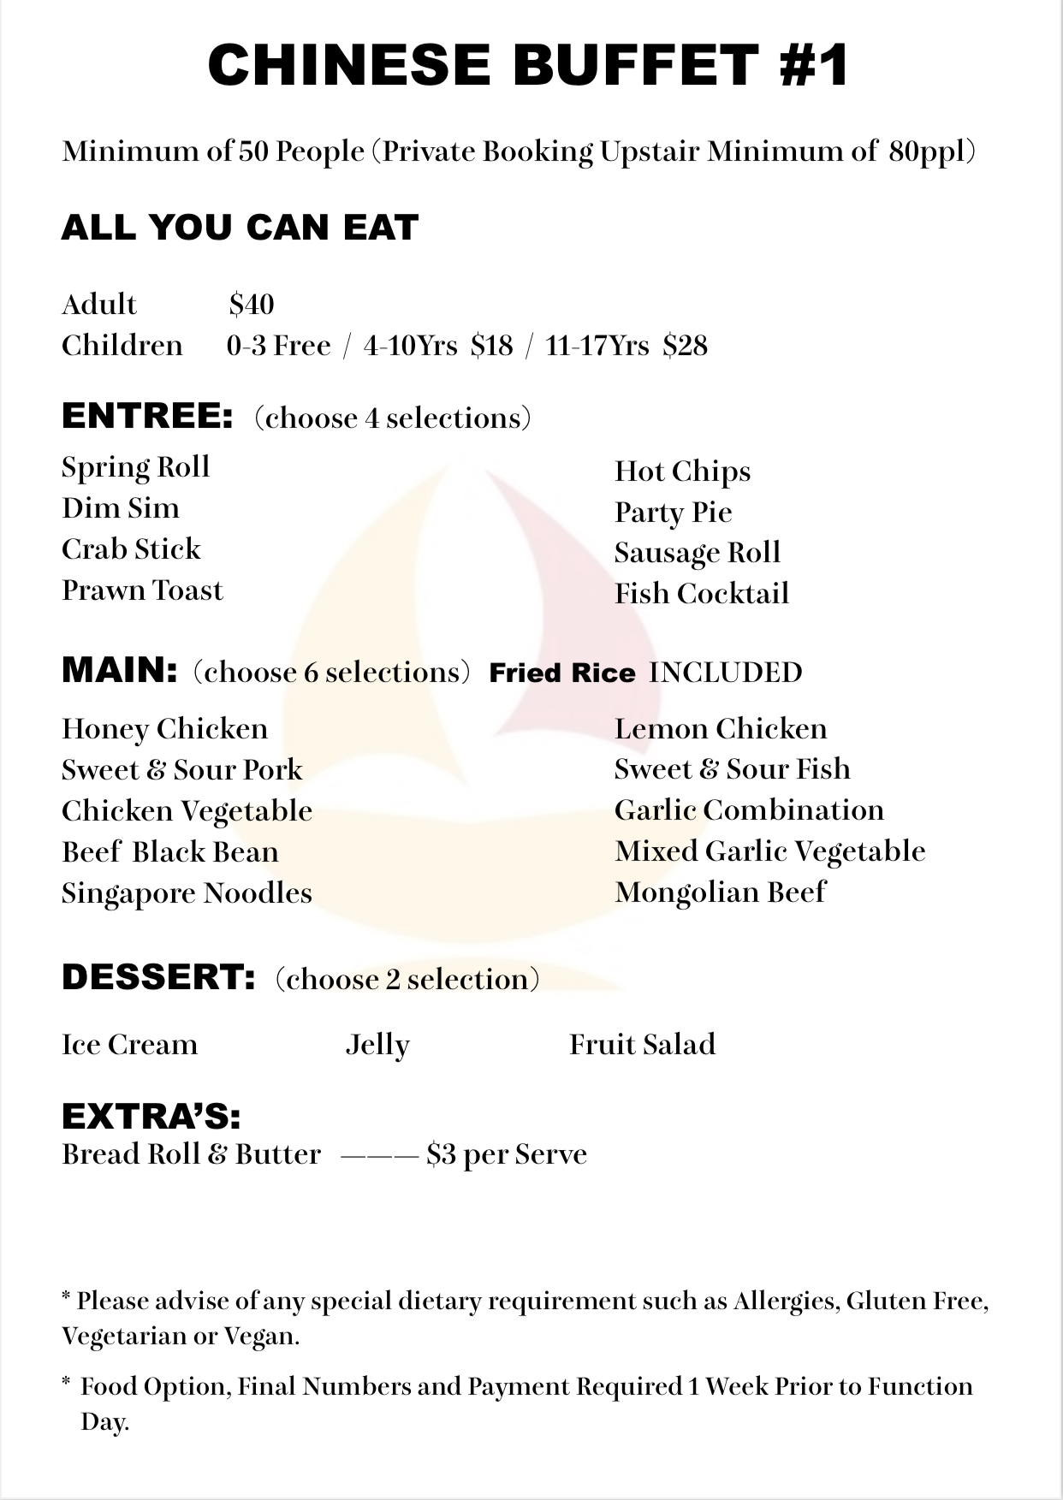

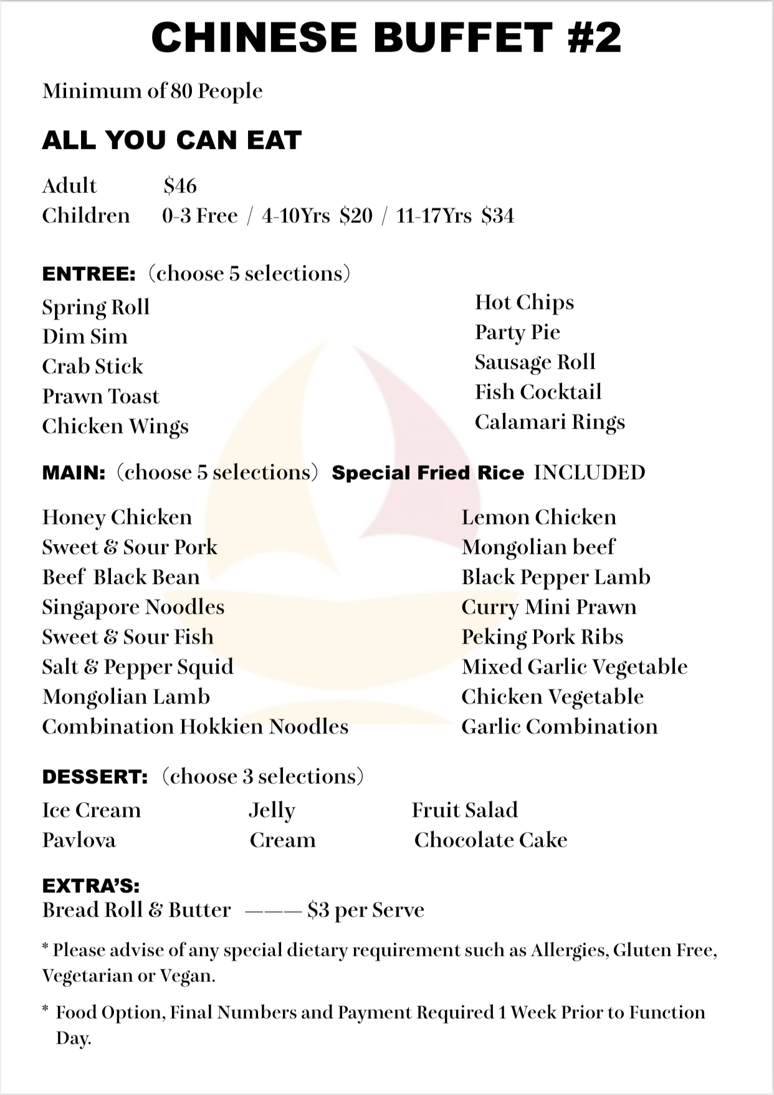

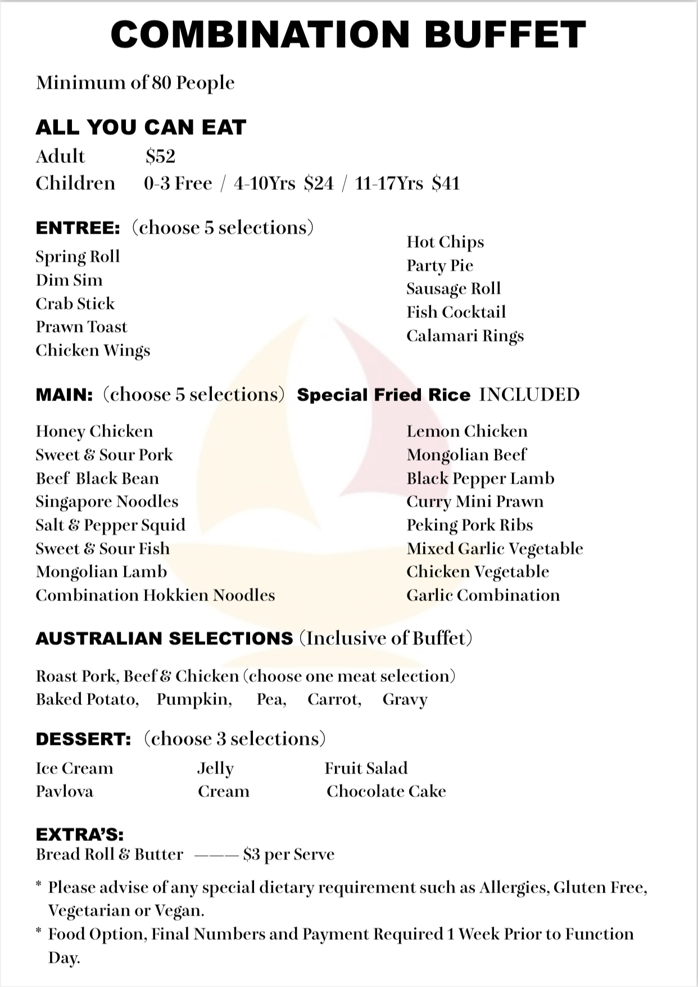

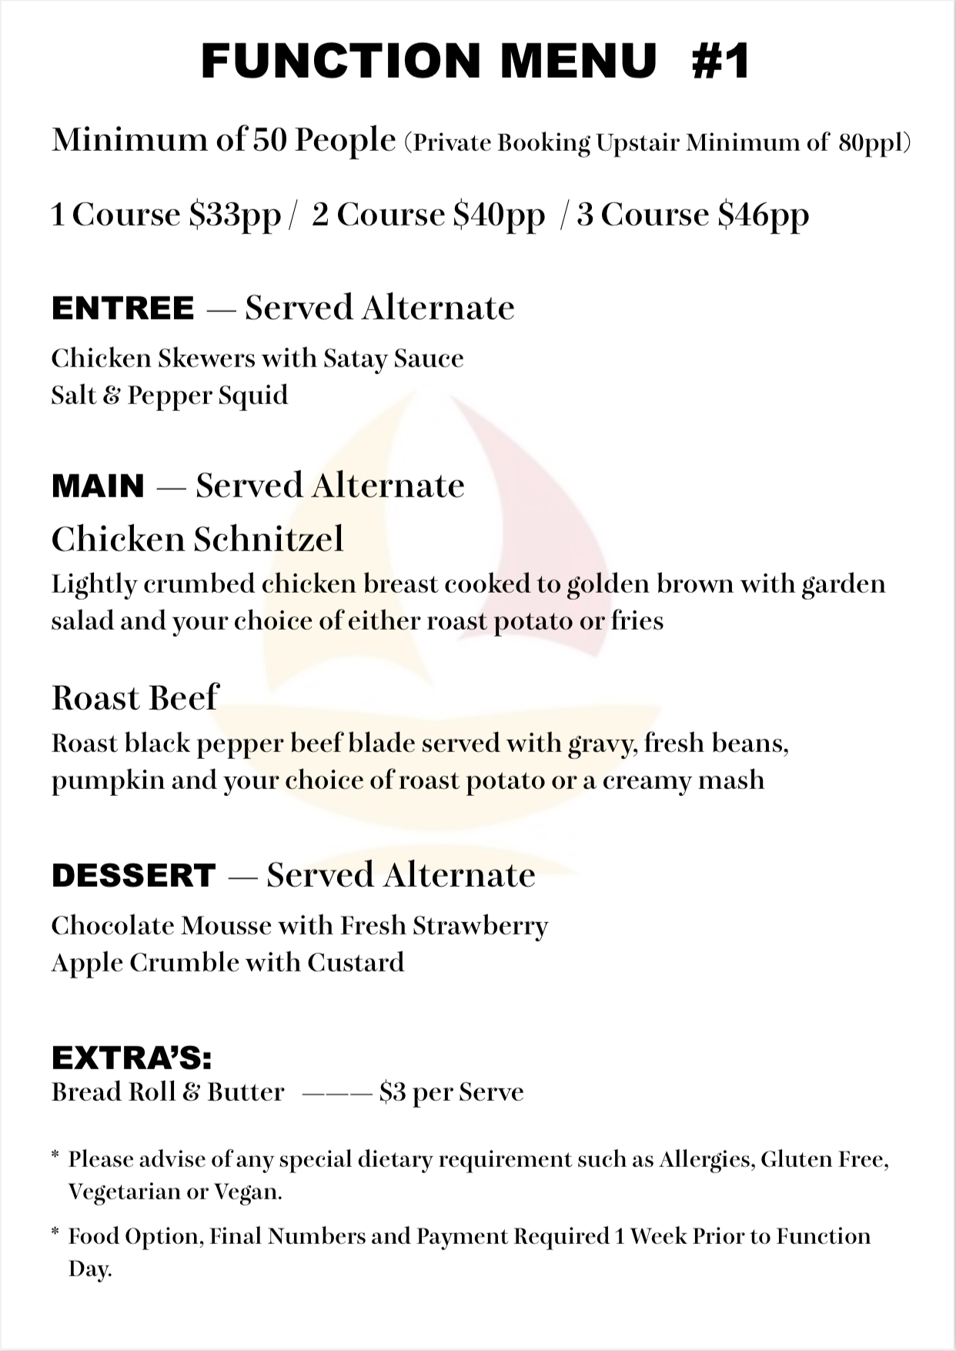

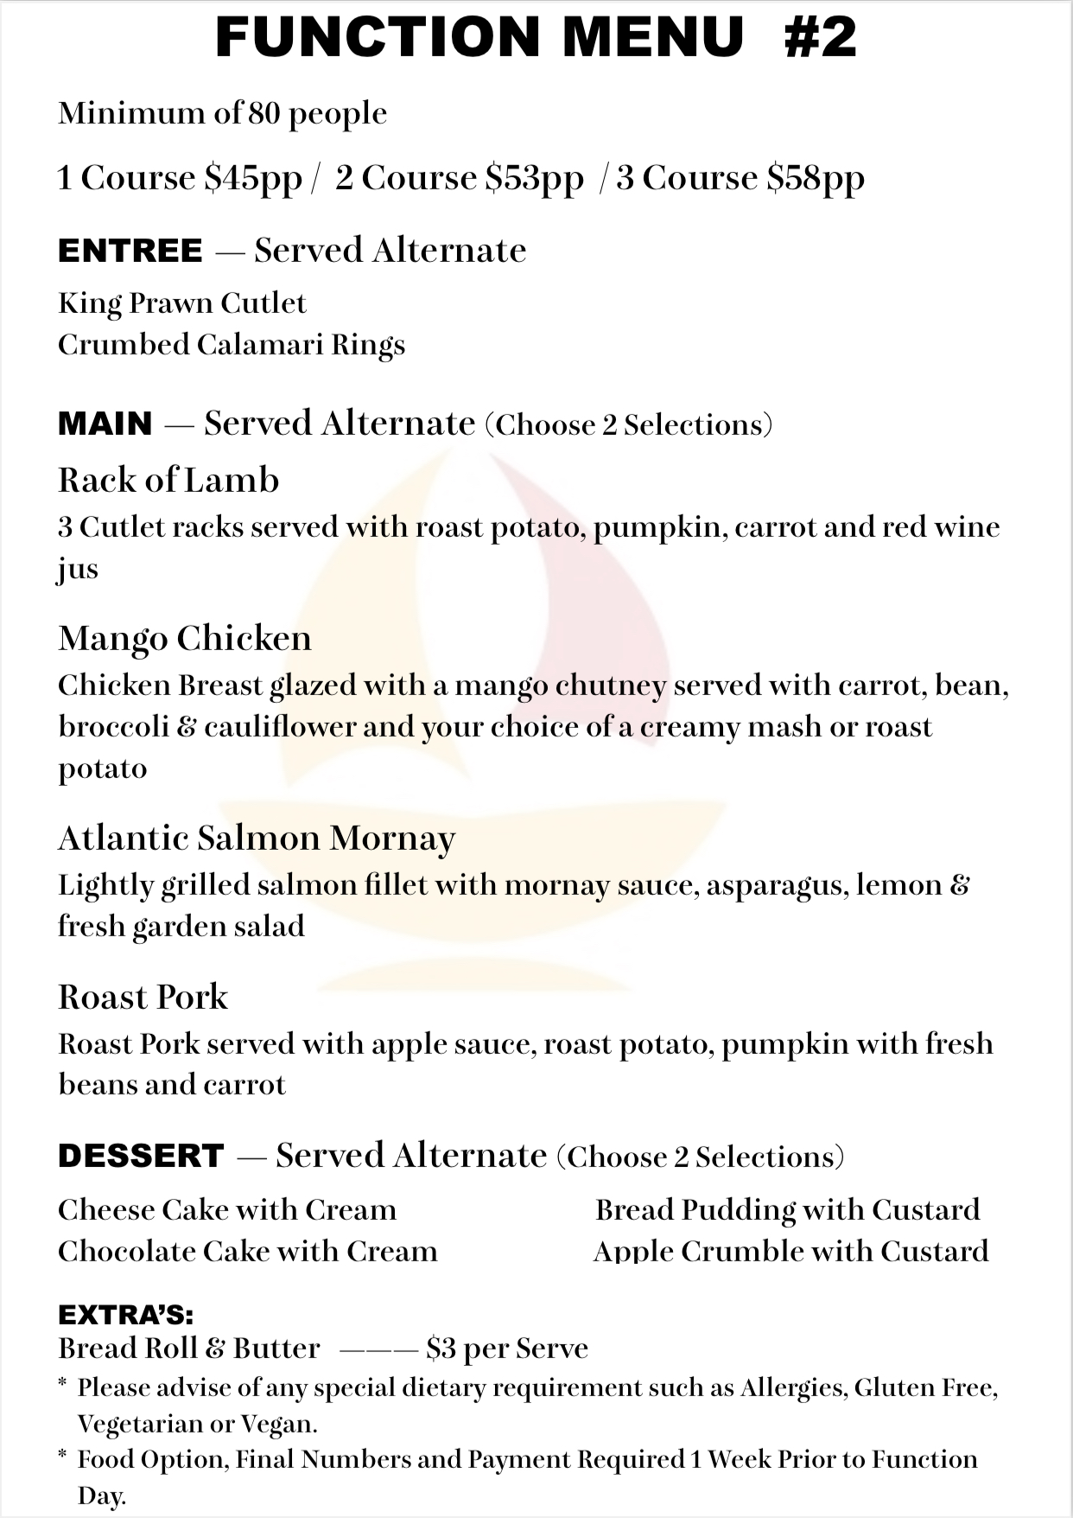

Function Booking Sheet

|  |  |  |  |  |  |  |
| --- | --- | --- | --- | --- | --- | --- |
| **Your Details** | | | | | | |
| **Name/s:** |  | | | | | |
| **Contact Number:** |  | | | | | |
| Address: |  | | | | | |
| Town |  | State |  | Post Code |  |
| **Email Address:** |  | | | | | |
| **Membership**  **Number:** |  | | | | | |

|  |  |
| --- | --- |
| **Function Details** | |
| **Date of Function:** |  |
| **Reason for Function:** |  |
| Expected number of  Guests: |  |
| Room Required:  **Room Hire:** | Upstairs (Function Centre) $350.00 room hire required. Paid?  Downstairs (Sandbar) Not private booking |
| **Arrival Time:** |  |
| Decorations to be put up: | YES / NO  Set-up time:  Themed ?  **NO CONFETTI OR POPPERS** |
| Electronics: | MUSIC (LIVE ENTERTAINMENT): YES / NO Setup time? IPOD: YES / NO  TV required: YES / NO |
|  |  |

|  |  |
| --- | --- |
| Courtesy Bus  required: | YES / NO |
| **Catering required:**  Menu required  **Public holidays**  **add**  **15% surcharge** | YES / NO |
| **Service Time:** |  |
|  |  |
| Tea / Coffee Station required: | YES / NO *Cost: $1.50 per person |
| Beverages: (circle)  **Public holidays**  **add**  **15% surcharge** | Bar Tab  YES/NO  AMOUNT:  Beer wine soft drink YES/NO  Open Bar YES / NO |
| Additional Extras: (state any you require) |  |

|  |  |  |  |  |
| --- | --- | --- | --- | --- |
| **Office Use** | | | | |
| **Monies Paid:** | Amount: |  | Date: |  |
| Amount: |  | Date: |  |
| Amount: |  | Date: |  |

