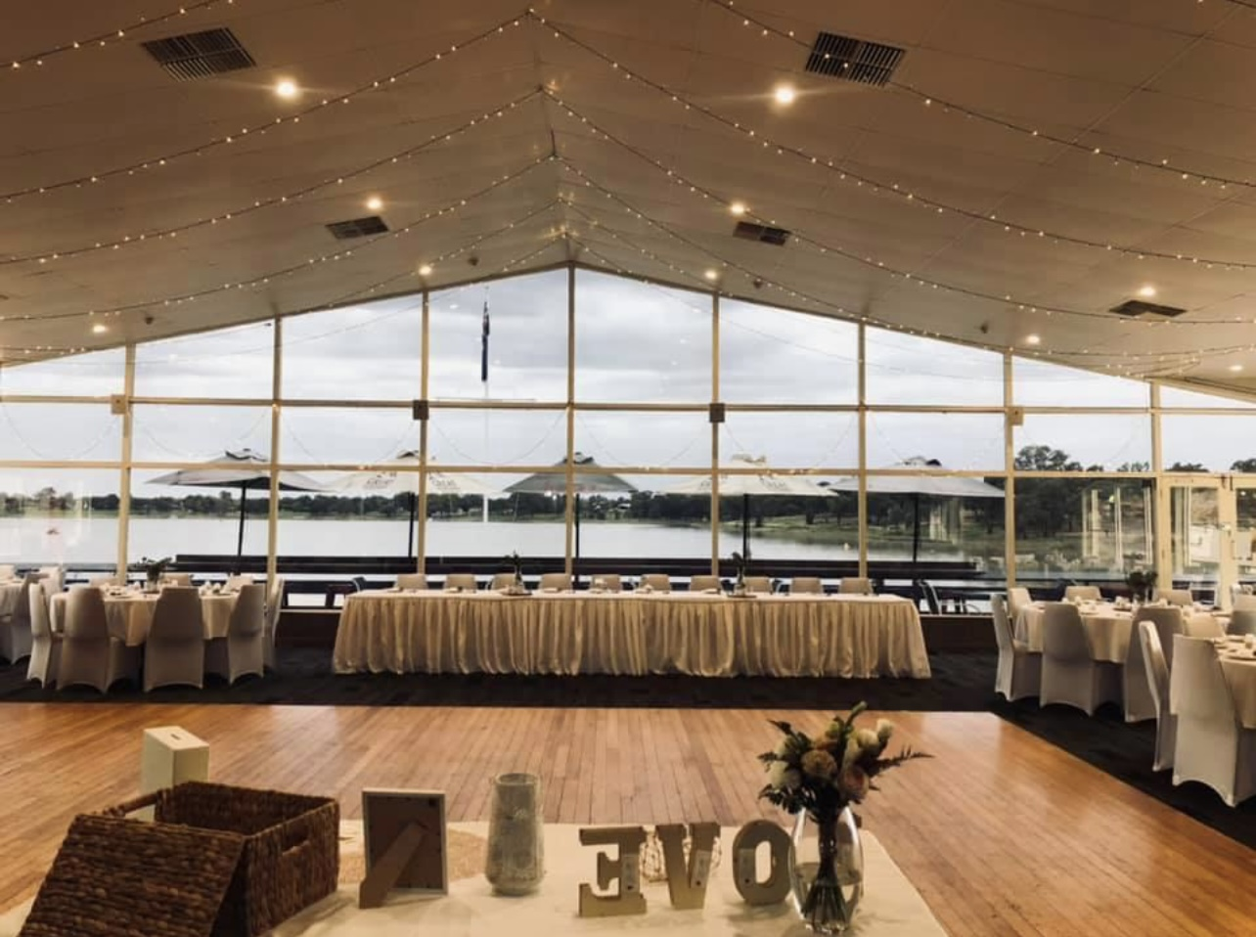

The Wagga Wagga Boat Club

Function Package

(Birthdays, Weddings, Anniversaries, Dinners & More…)

CONTACT INFORMATION:
Nelson Drive (Off Plumpton Road), Wagga Wagga NSW 2650
Telephone: (02) 6926 2300
Email: waggawaggaboatclub@bigpond.com
Website: www.waggawaggaboatclub.com
Find us on Facebook: The Wagga Wagga Boat Club
ABN: 23 001 064 106

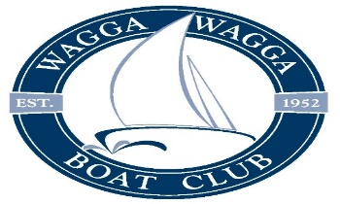

Why choose us?

Do you want a function venue with spectacular views, first class service and
fabulous food? Look no further than The Wagga Wagga Boat Club Function
Centre. Located on stunning Lake Albert, our second floor function facilities offer
an unmatched lake view with unique open air or inside areas.
Our recent refurbishment has seen some spectacular changes to the function
rooms creating a venue that cannot be beaten on location, atmosphere or value.
It allows you to enjoy the location, view and atmosphere no matter what the
weather is doing outside.

Function Areas
Upstairs Function area including the balcony and bar Privately is
available to hire for a very competitive price of $350.00 and can accommodate anywhere
from 20 to 120 guests seated with dance floor / or 180 guests seated without dance
floor.
Deck Booking Privately $300.00, if you would like your own private bar on the deck it will an Extra charge of $200.00

Downstairs Sandbar and Alfresco area is available with Zero
Room Hire fee but a $200 security deposit is required when making a booking.
This area is a public area and therefore people not from your
function may be present.

Full Bar Facilities

Offering the convenience of a Bar Tab for you and your guests, our bar facilities are
more than capable of catering to your every need. Beverage packages can be
arranged with our Function Manager.

Entertainment

Let us know your entertainment requirements and we can recommend a range of
suitable live entertainers for your special night. We also have iPod connectivity and
microphone available if you require.

Courtesy Bus

Forget about the worry of organizing travel arrangements and let our friendly staff take
care of your guests with pick up and drop offs in the local area. It’s all part of the
service.

Personal Service

You are invited to drop in and see Anna – our dedicated Functions Manager. Discuss
the details of your function and let her attention to detail and expertise make your
function one to remember.
Public Holiday
All public holidays will incur a 15% surcharge bar/restaurant

Menu’s

Crystal Restaurant
at
The Wagga Wagga Boat Club
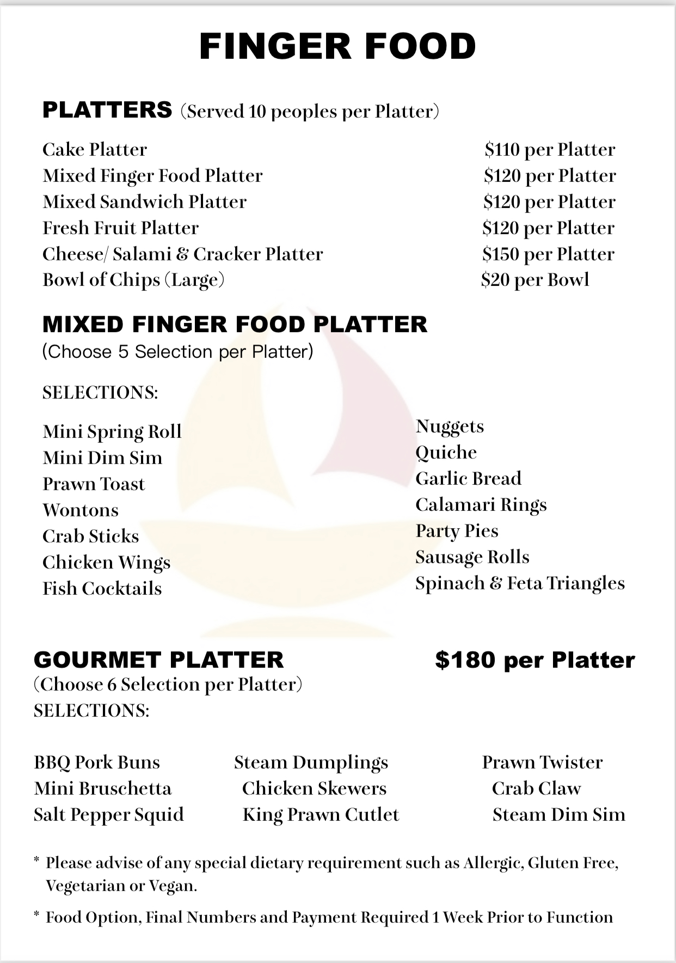
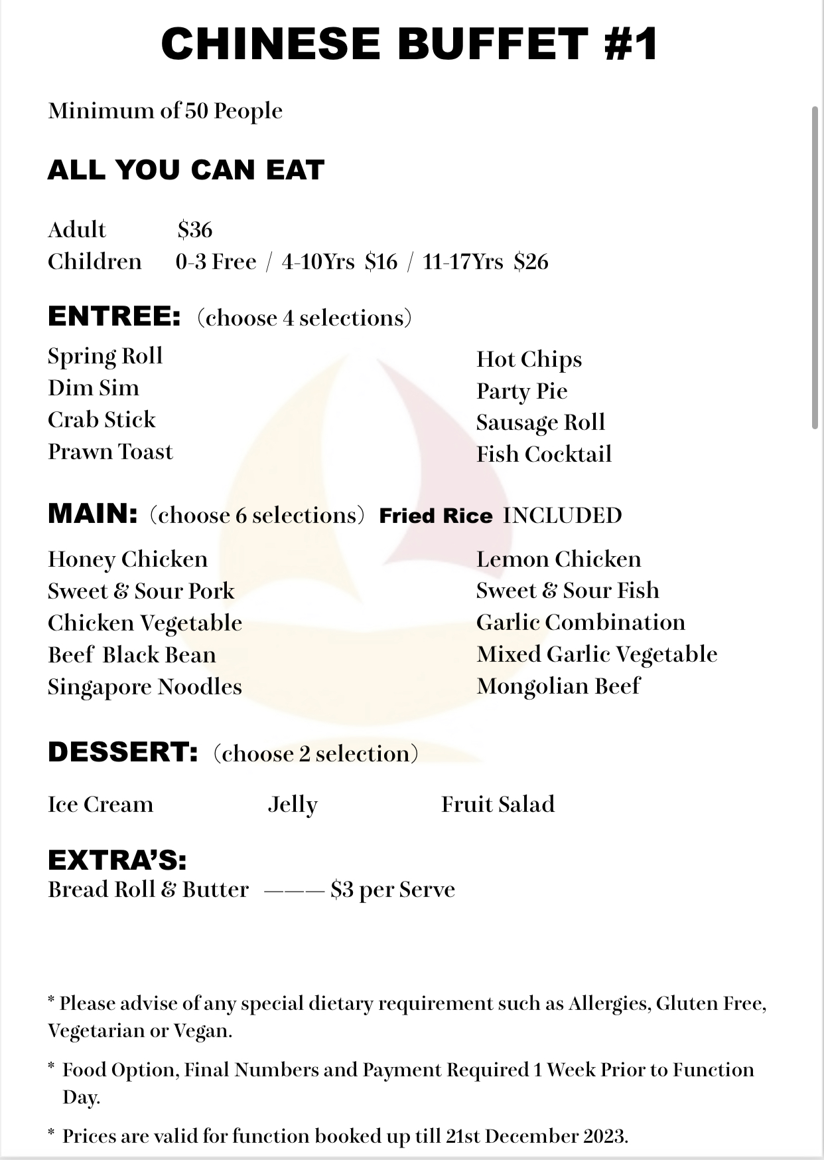

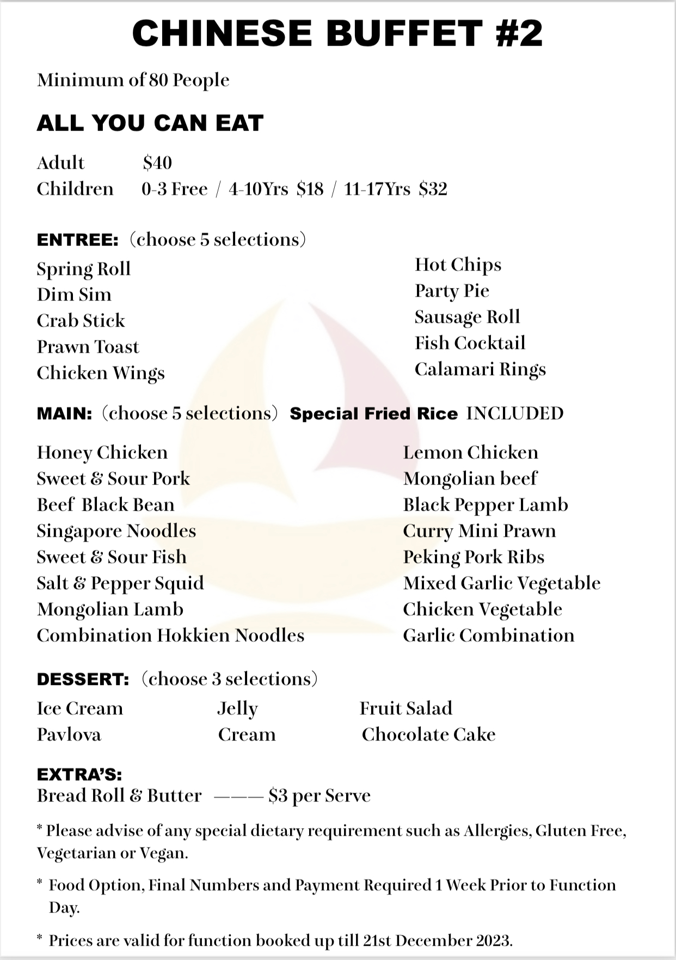
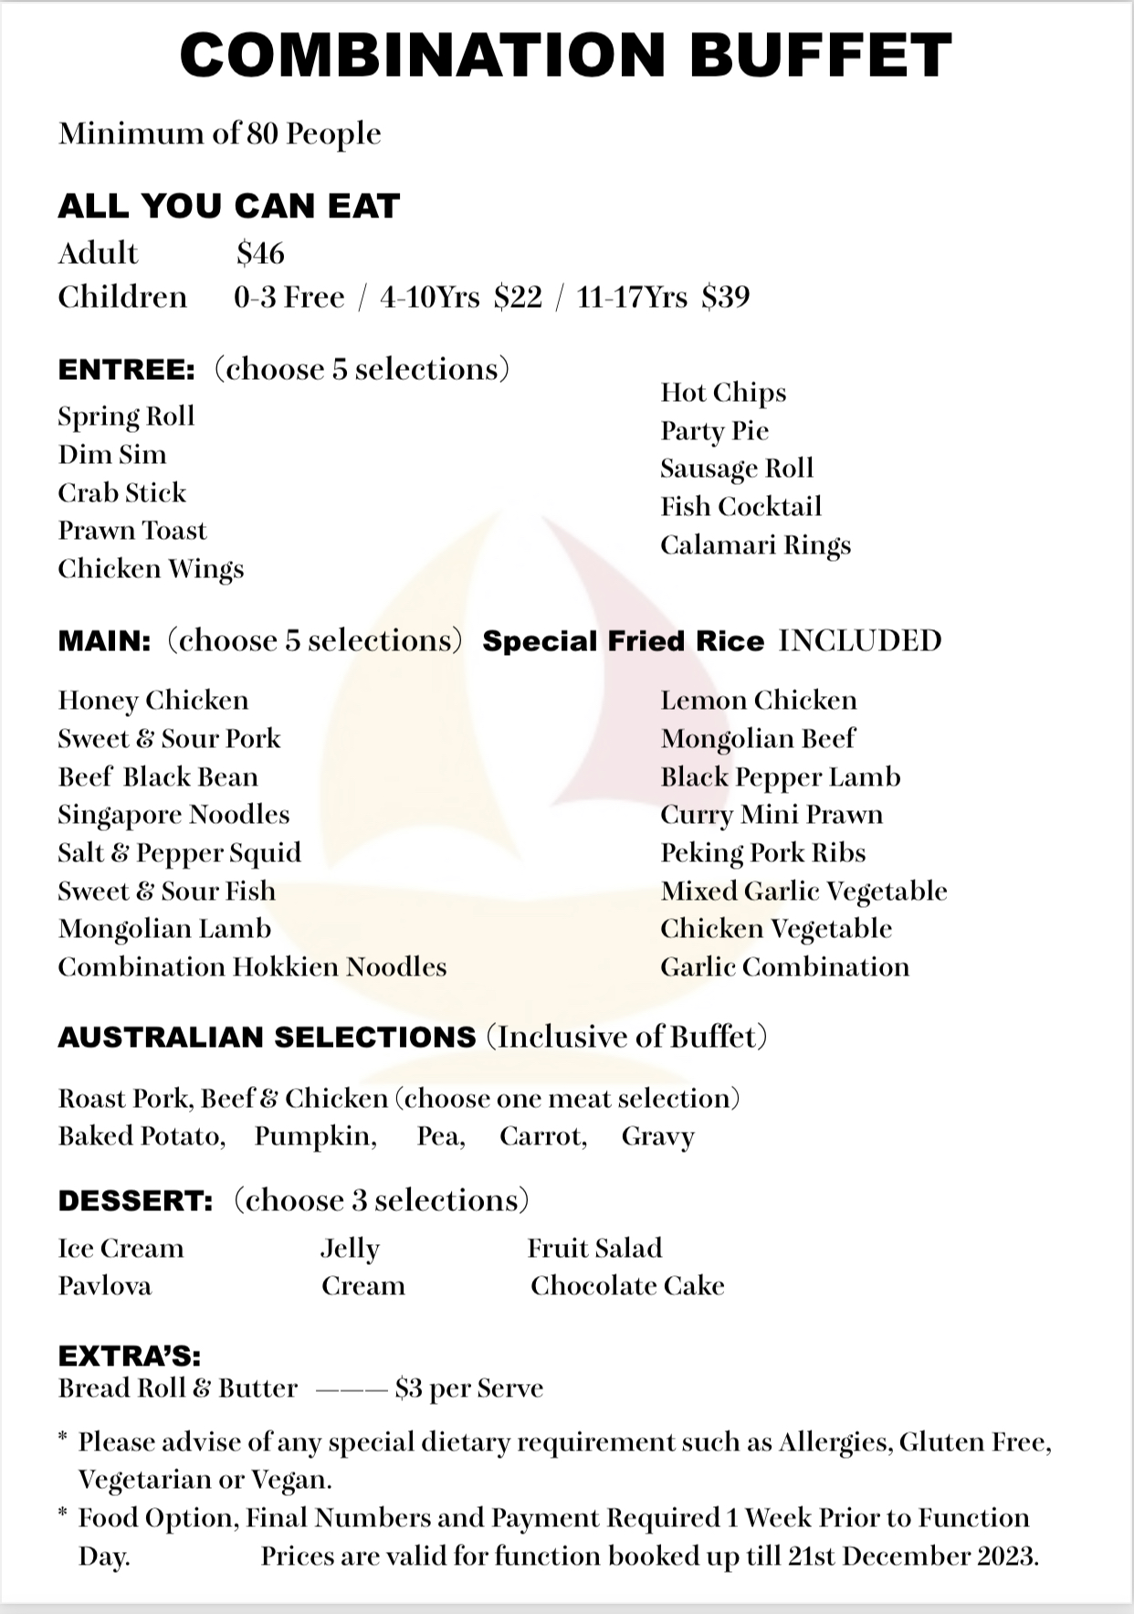
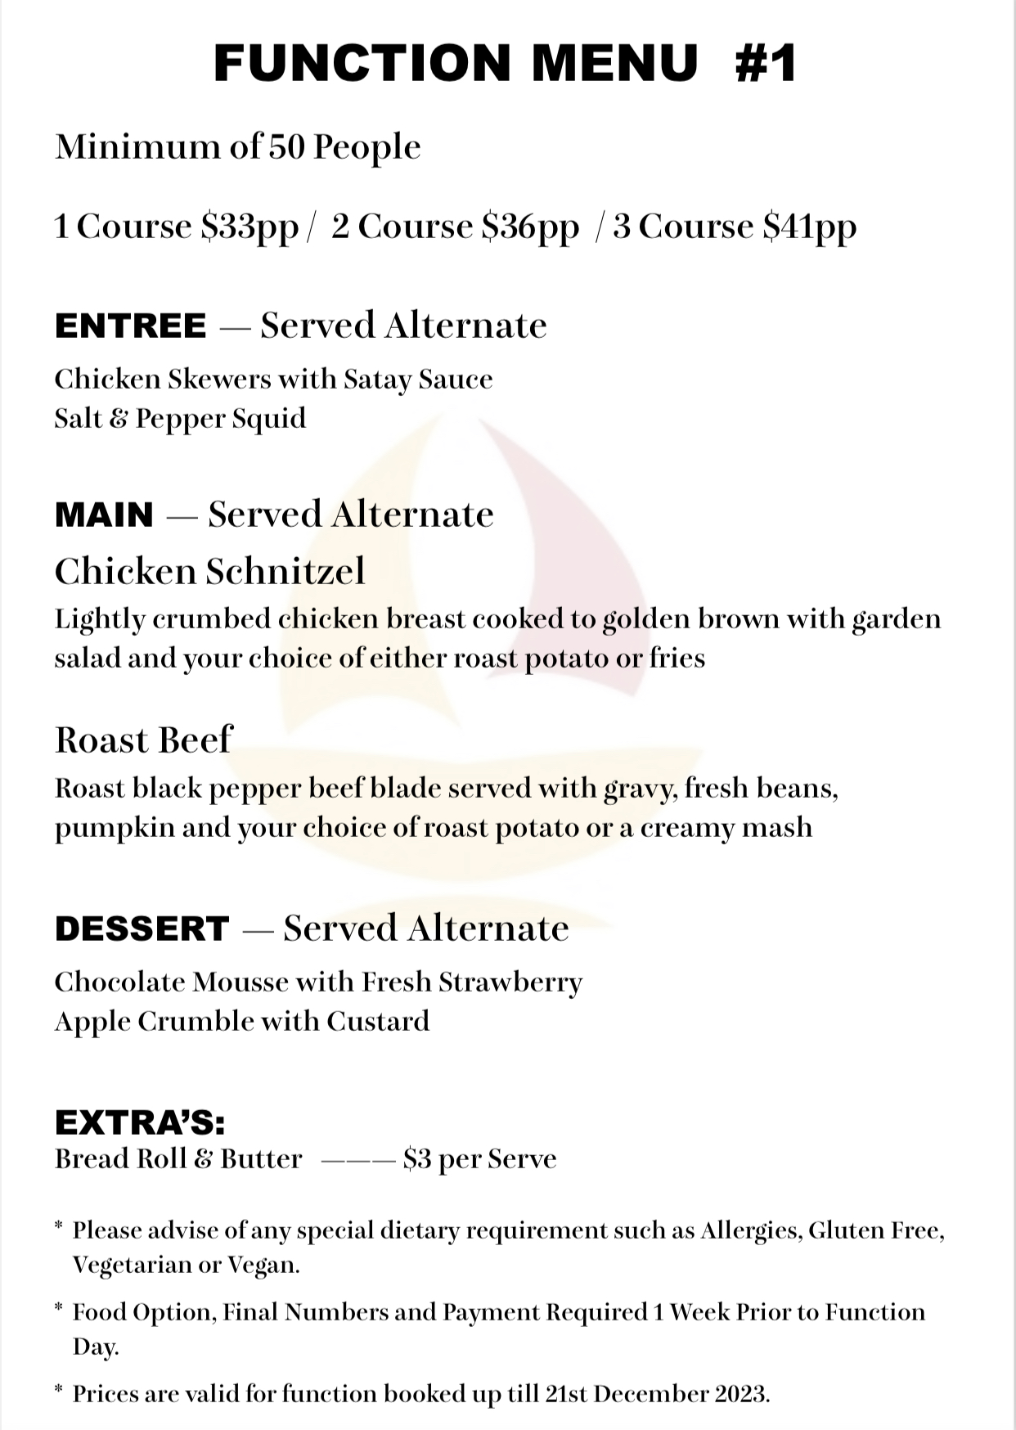
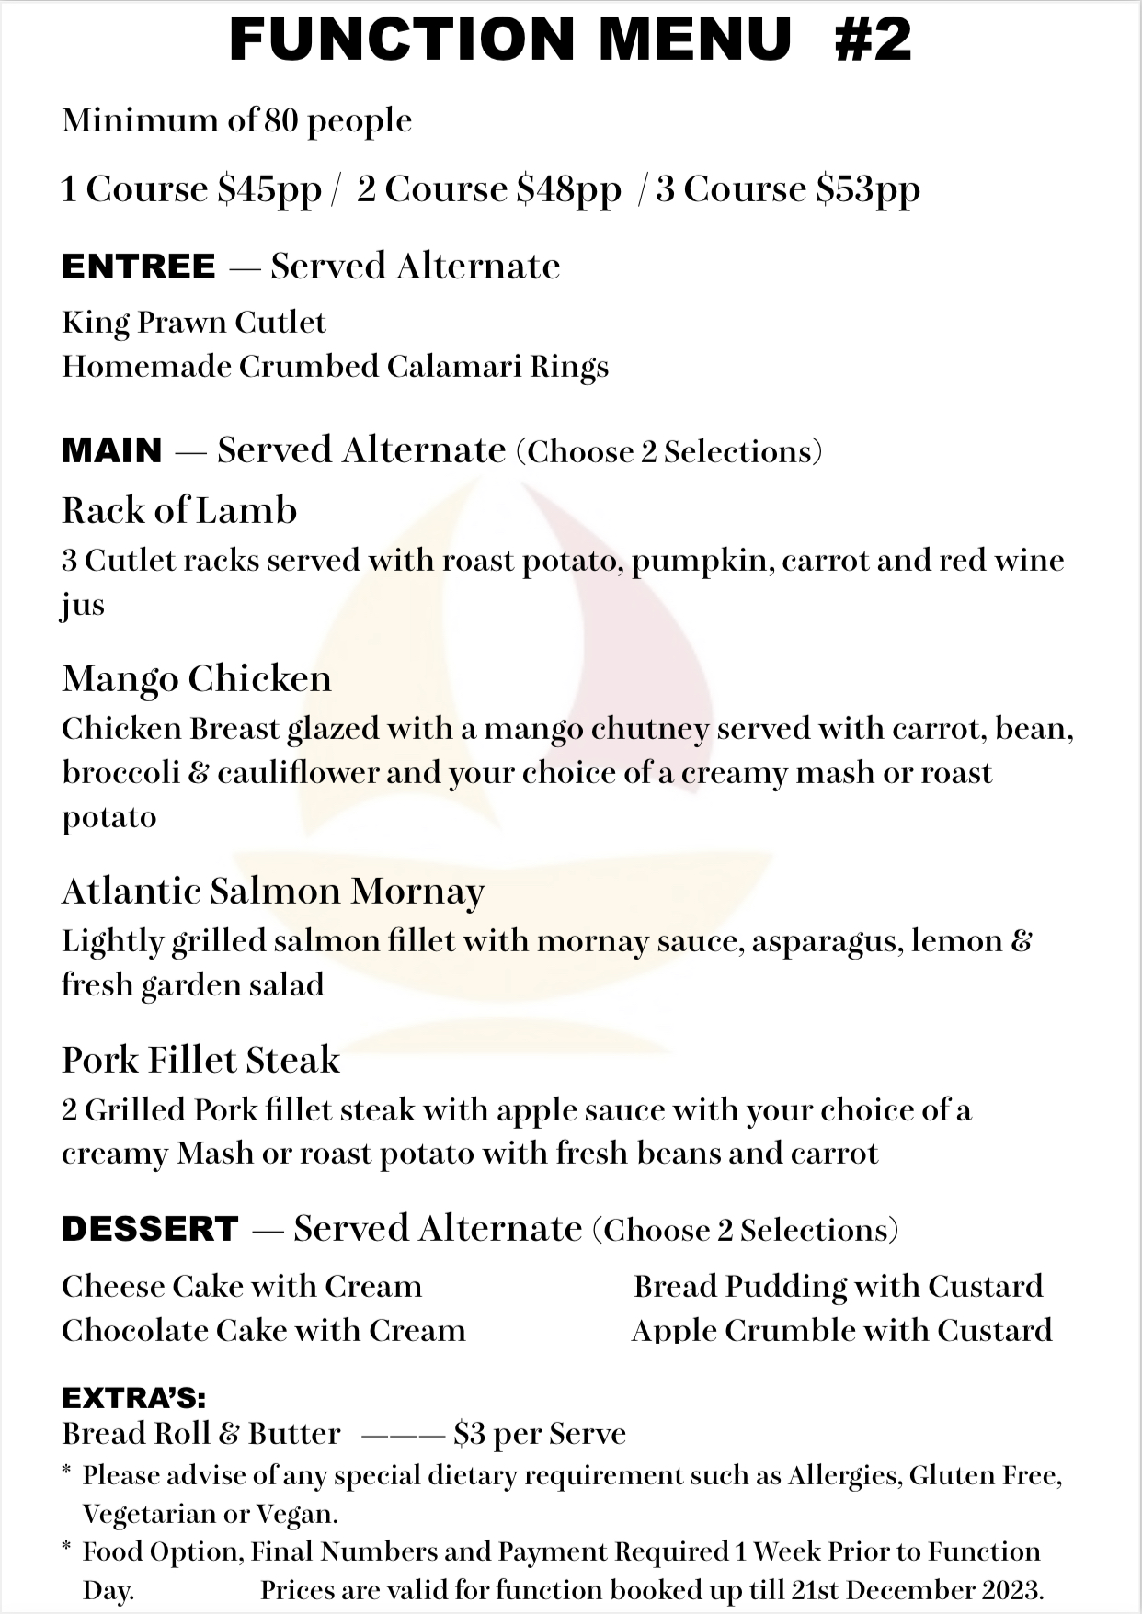

Function Booking Sheet

Your Details
Name/s:
Contact Number:
Address:
Address: | Town |  | State |  | Post Code
Email Address:
Membership
Number:

Function Details
Date of Function:
Reason for Function:
Expected number of
Guests:
Room Required:  Room Hire: | Upstairs (Function Centre) $350.00 room hire required. Paid?  Downstairs (Sandbar) Not private booking
Arrival Time:
Decorations to be put up: | YES / NO  Set-up time:  Themed ?  NO CONFETTI OR POPPERS
Electronics: | MUSIC (LIVE ENTERTAINMENT): YES / NO Setup time? IPOD: YES / NO  TV required: YES / NO

Courtesy Bus  required: | YES / NO
Catering required:  Menu required  Public holidays  add  15% surcharge | YES / NO
Service Time:
Tea / Coffee Station required: | YES / NO *Cost: $1.50 per person
Beverages: (circle)  Public holidays  add  15% surcharge | Bar Tab  YES/NO  AMOUNT:  Beer wine soft drink YES/NO  Open Bar YES / NO
Additional Extras: (state any you require)

Office Use
Monies Paid: | Amount: |  | Date:
Monies Paid: | Amount: |  | Date:
Monies Paid: | Amount: |  | Date:

